 |  |  | Physical Education
 |  |  | Tchoukball Study Guide
History |  | - Tchoukball (Toookball) is an indoor team sport developed in the 1970’s by Swiss biologist Hermann Brandt. His aim was to develop a team sport that didn’t involve the injuries that plagued other sports. Tchoukball combines elements of team handball, volleyball and squash. Tchoukball is an international sport, played in Brazil, Canada, China, Czech Republic, Great Britain, Hong Kong, India, Italy, Japan, Macau, Singapore, Switzerland, Taiwan and the United States. The Federation International of Tchoukball (FITB) was founded in 1971.
Playing Area |  | - Usually played on an indoor court  - Approximately 88ft by 52ft.  - At each end there is a “Frame” (Pictured on page 2)  - “Forbidden Zone” – semi-circle shaped area measuring 10ft in radius from the Frame.  - The “Forbidden Zone” lines are considered part of the zone.  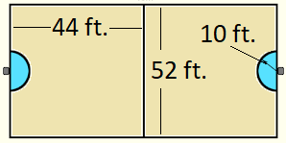
Traditional Positions: |  | 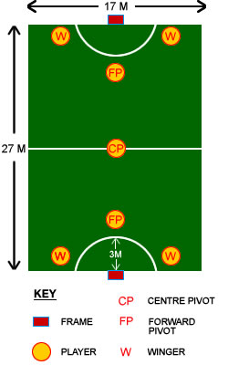  - 2 Right Winger (Shooters/Defenders)  - 2 Left Winger (Shooters/Defenders)  - 2 Forward Pivot (shooters/Defenders)  - 1 Center-Pivot (Center pivot)  Each side of the court comprises a left wing, right wing and a center forward, while the center-center usually stays near the middle of the court. The wings and generally in charge of shooting although in some cases the center forward can also take the shot. The center forwards are in charge of coordinating the first line defense while the Center-Center takes charge of the second line defense. However, formations are not limited to this one style of play.
Objective: |  | - 2 Teams of 7 players each complete to score points. The team with the most points at the end of the game.
Scoring: |  | - In Tchoukball, attacking is not limited to one side and either team can score at either side of the court.  - A point is scored when the ball rebounds after hitting either of the 2 frames and touches the ground outside the forbidden zones or any part of the defending player’s body below the knees or touches the defending player while he is still in the forbidden zone.  - A point is given to the defending team when the attacking team misses the frame, or when the ball lands inside the forbidden zone or lands out of bounds.  - After a point is scored, the defending teams takes control of the ball. Start play by playing the ball on the ground and saying “Tchouck” (ToooK).
Fouls |  | The non-offending team takes possession of the ball when a foul is committed and has to start the ball where the foul was made by tapping the ball with 2 hands on the ground before passing.
- The ball should never touch the ground during passing. (Turn over)
- Defense may not intercept a pass whether intentionally or not while the other team is passing.
- Defense may not block passes or defend offensive players.
- The ball makes contact with any part of the body below the knees.
- Holding the ball for more than 3 seconds. (Turn over)
- The shot hits the frame (metal part) or misses the rebounder results in a point for the defense.
- Shot at rebounder must be taken before or after three passes. If not, turn over
- There are more than 3 successive shots at the same frame: Assuming the ball is continuously caught, the ball can only be shot at the same frame a maximum of 3 times in a row.
- Restart must be a pass, restart cannot be a shot at the frame.
- The player with the ball make take up to three steps before passing or shooting the ball. If more than three steps are taken it is a turn over.

